Wing Landmarks:

Using Clic-> Coo\

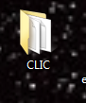1. Open CLIC folder

2. Select “clicwin64.cmd”

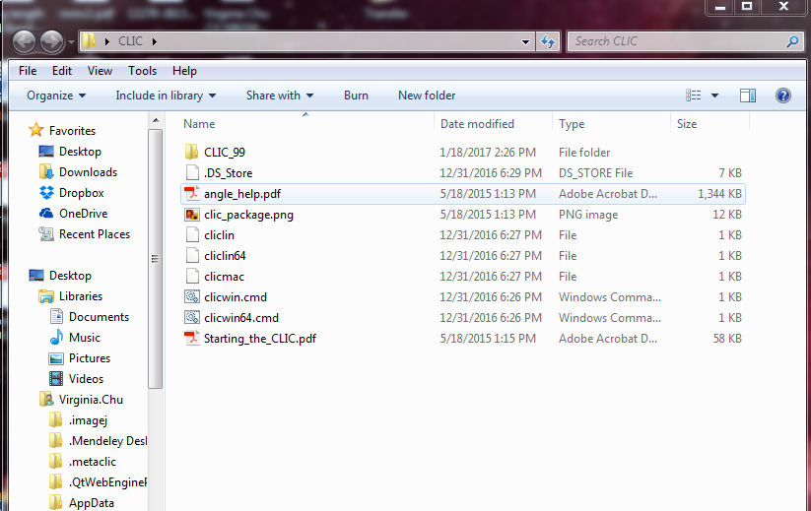

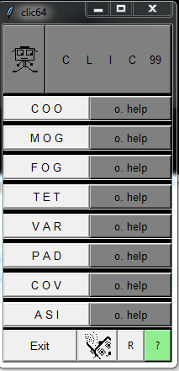3. Select COO

4.COO opens to last used folder where you will select image files for landmarking

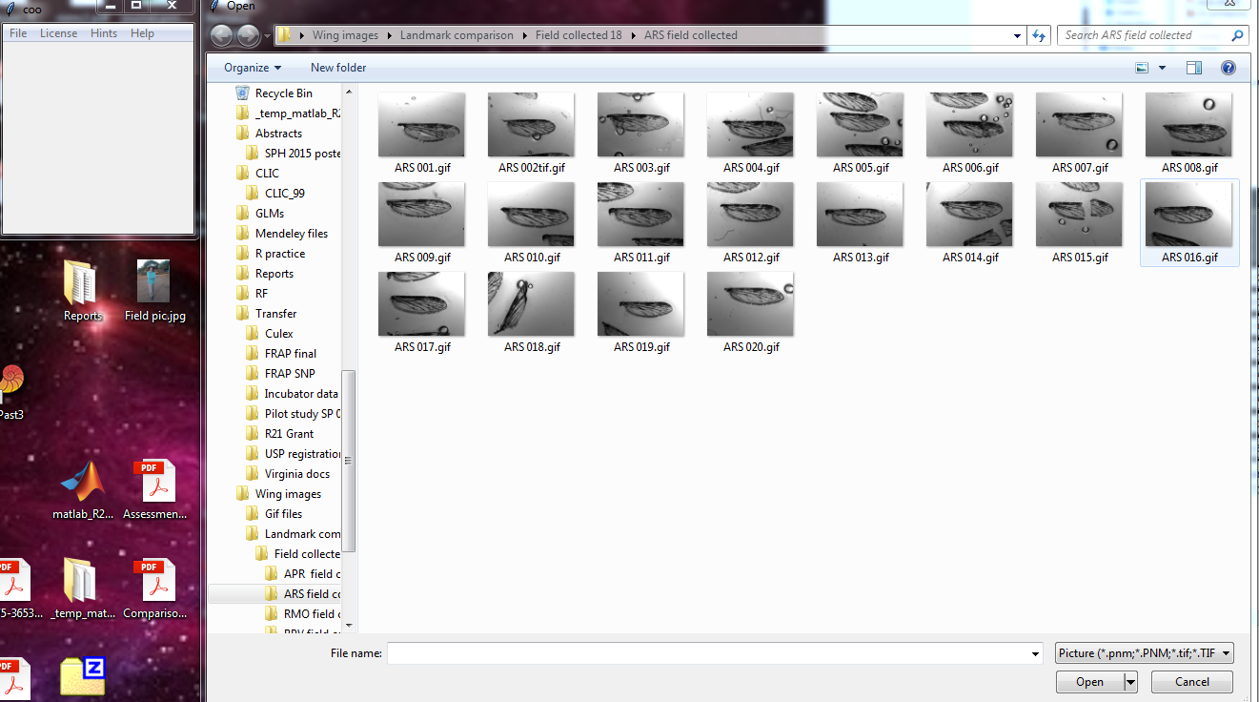

5. Select a file

6. Then COO opens it up

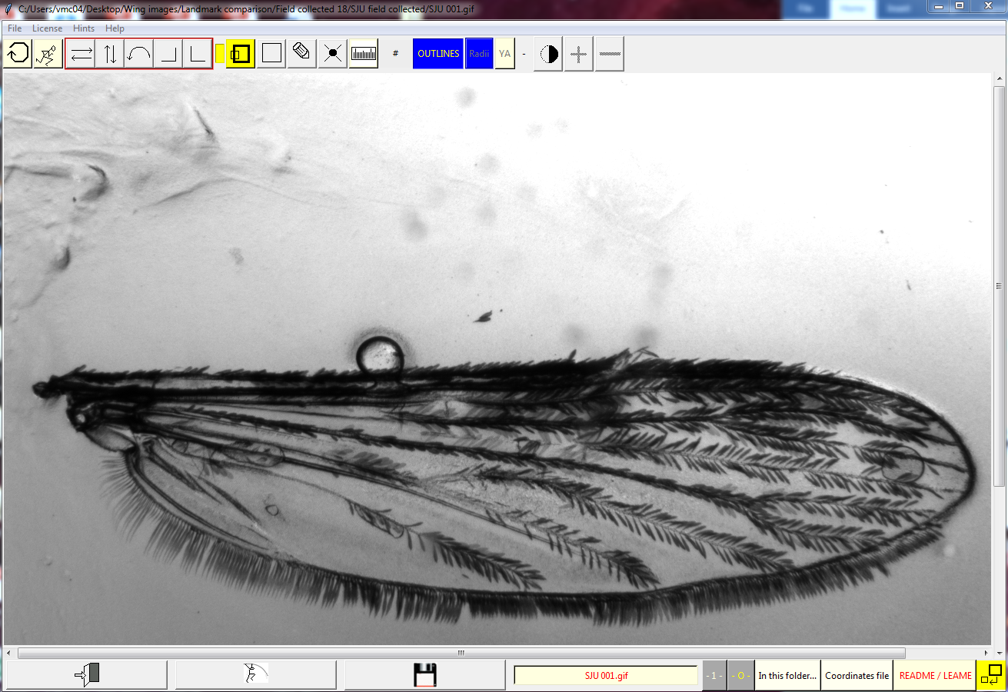

7. Click the “Running man” to begin



8.Select landmarks.

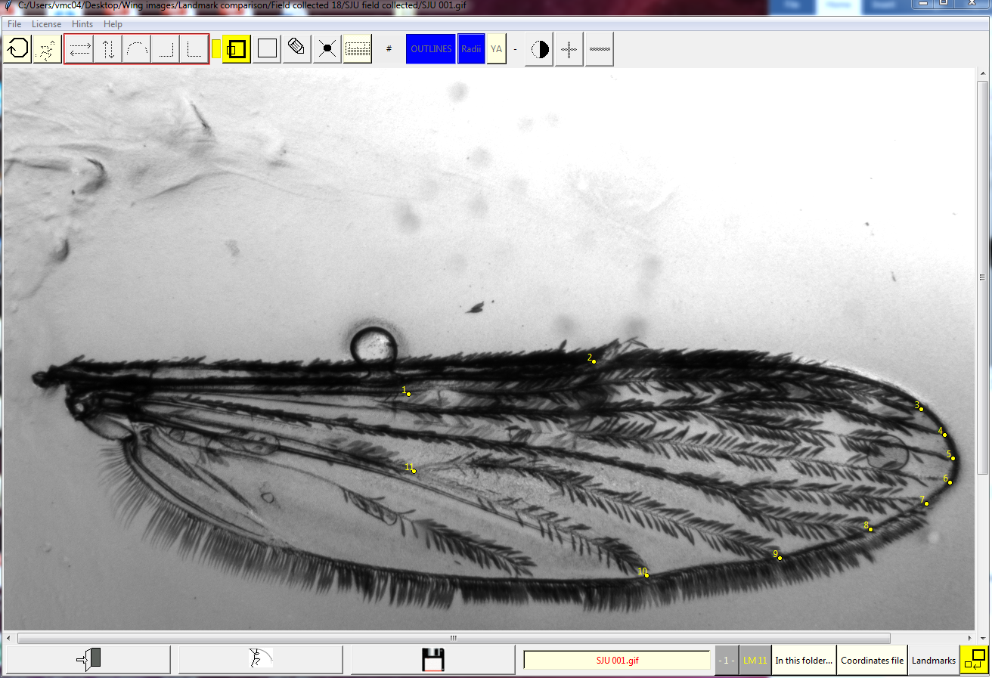If you make a happy little accident, click the erase button or “e”

9. When you are done, click save (floppy disk)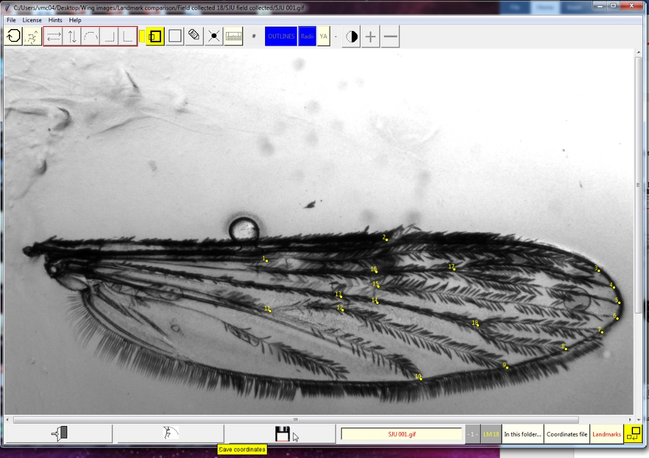

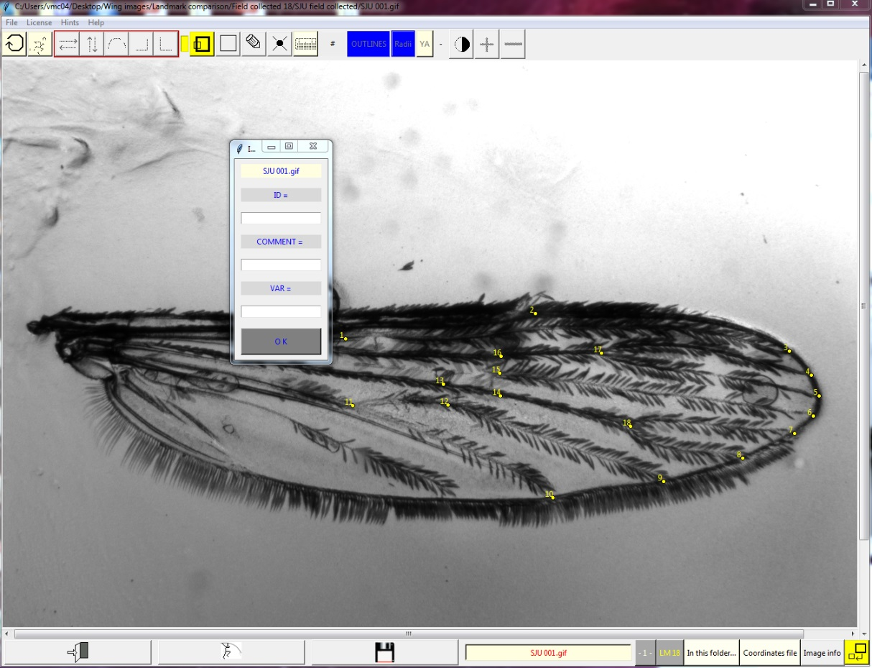10. Save landmarks- ID=SJU001, Comment= 13 or 18 landmarks

11. When you are all done, close the program by going File-> Exit

12. Find the .txt file. Should be something like “coordLast.txt” or “coord_May08.txt”

13. Import .txt data to excel

Excel file->Data->From Text-> Select .txt file -> ⮱Delimited ->⮱Tab and select cell you want it to start in

CLIC toolbar

(From left to right)

1. Get new image

2. Run, start getting landmarks

3-7. Rotate image around

8. Magnify

9. ?

10. Change cursor type

11. Erase

12. Ruler for scaling (not needed for landmarks)



1 2 3 4 5 6 7 8 9 10 11 12